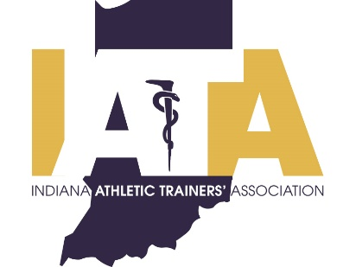 | PRESS RELEASE
 | FOR IMMEDIATE RELEASE
 | Scott Sell, Communications Chair
 | Phone: (812) 240-5098
 | scott.h.sell@gmail.com

Pete Dewar Awarded IATA Joe A. Harvey Distinguished Service Award

Indianapolis, IN (12/31/2020)---- Pete Dewar, athletic, has been chosen as the 2018 Joe A. Harvey Distinguished Service Award winner by the Indiana Athletic Trainer’s Association (IATA). Due to the ongoing COVID pandemic, Pete will be presented his award during a special virtual ceremony with the other members of the 2020 award class.

The Indiana Athletic Trainers’ Association (IATA) will honor Pete Dewar with the Joe A. Harvey Distinguished Service Award. Pete served the IATA for many years, most recently as the Communication Committee Chair. Pete is also actively involved with the World Federation of Athletic Training and Therapy.

Formal Criteria for the IATA Joe A. Harvey Distinguished Service Award
The IATA Joe A. Harvey Distinguished Service Awrad is given to an individual who has made special contributions to the IATA, the field of Sports Medicine and has been an advocate of the Athletic Training Profession. To be eligible for this award a person must be an Indiana state licensed athletic trainer, make contributions/support to the IATA and the profession of Athletic Training, and make contributions to healthcare in Indiana. For more information visit http://www.iata-usa.org/.

####

The Indiana Athletic Trainers' Association is a professional membership association for athletic trainers and athletic training students in Indiana. The IATA is committed to the provision of quality healthcare for the physically active individual and strives to advance the athletic training profession. For more information please visit www.iata-usa.org

