Relaxation – May 2017

Summer is a good time to recharge. This month, focus on your breathing and relaxation!! Take some time to do one, two or all of the exercises below.

Talk with your mentee or mentor on which one you liked/disliked. Are there any techniques you use currently? Share with your mentee or mentor!

5 Simple Breathing Exercises to Lower Your Stress Levels
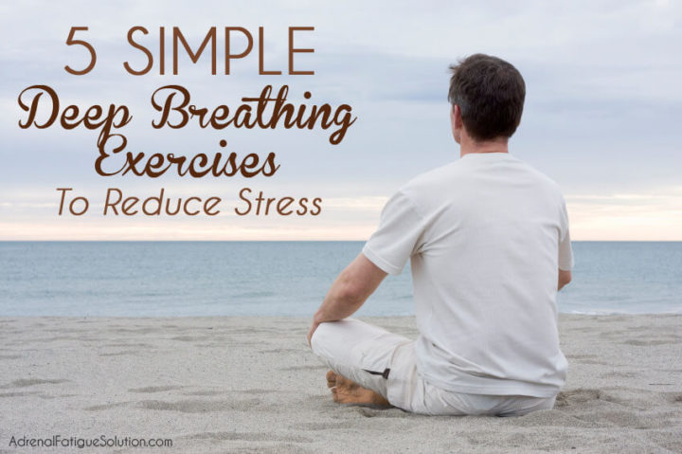
We know beyond any doubt stress can be detrimental to our health, and the fact is that record numbers of us are now reporting feeling stressed. It might be work-related, family issues or simply having a lot on our plates, but stress is something we need to combat if we are to lead healthy, happy lives.
In today’s post, I’m going to share a few simple breathing exercises that will help to lower stress levels. All of these can be practiced at home or in the office.

Belly Breathing
The first thing you need to learn to do is what’s called Belly Breathing. This is the most basic of the breathing methods we have at our disposal, and therefore is the one you should master before trying out the others. It’s very simple, and requires just a few steps:
- Sit down comfortably, or lay down on a yoga mat, depending on your personal preference.
- Place one of your hands on your stomach, just below your ribcage. Place the second hand over your chest.
- Breathe in deeply through your nostrils, letting your first hand be pushed out by your stomach. You should find that your chest stays stationary.
- Breathe out through your lips, pursing them as if you were about to whistle. Gently guide the hand on your stomach inwards, helping to press out the breath.
- Slowly repeat between 3 and 10 times.
You should begin to feel relaxed as soon as you have repeated the Belly Breathing exercise two or three times, but keep going for as long as you feel you need to. After you have mastered this breathing exercise, there are four additional methods for you to try, ranging in difficulty.

4-7-8 Breathing
The method which we call 4-7-8 Breathing also requires you to be sitting down or lying comfortably. Here are the steps you need to follow:
- Get into the same position as you did for the Belly Breathing exercise, with one hand on your stomach and one on your chest.
- Breathe in slowly but deeply. Take 4 seconds to breathe in, feeling you stomach move in the process.
- Hold your breath for 7 seconds.
- Breathe out as silently as you can manage, taking 8 seconds. Once you reach 8, you should have emptied your lungs of air.
- Repeat as many times as you need, making sure to stick to the 4-7-8 pattern.

Roll Breathing
If you are looking for a breathing exercise which you can do comfortably sitting down, try the Roll Breathing method. Its aim is not just to relax, but also to encourage the full use of your lung capacity. Beginners are advised to lie down, but after your first time you should find it just as easy to sit and complete this exercise. Follow these steps:
- Position yourself with your left hand on your stomach, and place your right hand over your chest. Your hands should move as you inhale and exhale.
- Take a deep breath from your lower lungs; breathe slowly, ensuring that the hand over your chest doesn’t move as you take the breath. Make sure you are using your nose to breathe in, and then exhale using your mouth.
- Repeat the deep breath up to 8 times. On the ninth repetition, once you have filled your lower lungs, take a breath which will move your chest up, as you would normally breathe. This will fill your entire lung capacity.
- Gently exhale through your mouth, being sure to empty your lungs as you do so. While you exhale, make a small whooshing noise. You should notice that both of your hands are moving back towards your body, as your stomach and chest fall.
- You should practice this method for between 4 and 5 minutes. When you exhale, you should be able to feel a tangible difference in your stress levels.

Morning Breathing
While the above three exercises can be completed whenever necessary, the next method is called Morning Breathing and, as the name suggests, should be practiced once you have woken up. It aims to relax your muscles after a good night’s sleep, and will help you to minimize tension for the remainder of the day – so you can start as you mean to go on. Here are the steps to follow:
- Stand up straight and, slightly bending your knees, bend your torso forward from the waist. Your arms should be hanging close to the floor, limply.
- Take a breath in slowly, returning to your original standing position. You should look like an inflatable ghost you may see at Halloween: your head should be the last thing to straighten up.
- Exhale, returning to the position of being bent forward by the end of your exhale. Stand up straight once you have finished, stretching your muscles as required.

Deep Muscle Relaxation & Belly Breathing
Finally, the Deep Muscle Relaxation technique is the most time-consuming but can also be the most rewarding for your body. This works best when combined with the Belly Breathing that I mentioned earlier, and is a great way to attain the relaxation response. You will exercise each major muscle in turn, but pay most attention to any muscles that are causing discomfort or ache. To start, sit down in a comfortable position and focus on your Belly Breathing, closing your eyes if need be. Then do the following
- To relax your face, knit your eyebrows together and release.
- To relax your neck, tilt your head down towards your neck, and push your chin to your chest, then release.
- To relax your shoulders, make a shrugging motion, then release.
- To relax your arms, push both arms away from your torso, stretch them out, and then relax them by your side.
- To relax your legs, point your toes as far away as they will stretch, and then relax.

